
IBM Data Science Capstone Project Report

Project: Finding neighbourhoods in Toronto best suited for a high-end Indian restaurant

Maram Bharath Simha Reddy

Business Problem Introduction

Toronto is a thriving multi-ethnic and multi-cultural city in Ontario, Canada. The restaurant industry in Toronto boasts of options from a multitude of ethnic sources. I am particularly interested in Indian cuisine, which is becoming increasingly popular. My goal is to determine the best neighbourhoods for setting up one or more Indian fine-dining restaurants.

The popularity of Indian cuisine started growing with the influx of immigrants from India in the 1960s. While initially limited to neighbourhoods with large Indian communities, the popularity of Indian food has now reached a more general audience in metropolitan Canada, especially in Vancouver and Toronto. This popularity follows the growing attraction for Indian cuisine in the United Kingdom, where Indian restaurants are successful outside ethnic neighbourhoods.

Indian cuisine has a wide variety, reflecting the diversity of ethnic groups and geographical nuances. However, Indian cuisine in the West has largely been limited to North Indian dishes, primarily because of the larger North Indian immigrant community. However, this trend is changing. A much greater variety of Indian culinary styles are now available for consumption for diners in larger cities like Toronto.

The goal is to set up one or more Indian fine-dining restaurants which will offer a broad range of dishes from India. The focus will be on sit-down dinners for families and groups. Pricing will be high-end.

The target audience for this analysis are investors in the specialty ethnic restaurants. In this instance it would be an investor setting up an Indian restaurant, but this approach can be extrapolated to any other ethnicity as well.

Reference: https://www.thecanadianencyclopedia.ca/en/article/indian-food-in-canada

Sources of data

To determine the best neighbourhoods for opening an Indian restaurant I needed the following information:

Names of Toronto neighbourhoods

There are several sources for getting this information.

The Wikipedia page on Canada postcodes starting with M is one of them (https://en.wikipedia.org/wiki/List_of_postal_codes_of_Canada:_M).

Another more definitive source is the Canadian census data. I decided to us this for reasons given below.

https://www.toronto.ca/city-government/data-research-maps/open-data/open-data-catalogue/
In terms of geographical location, for the sake of simplicity, I decided to restrict the analysis to Toronto city and not include the nearby towns of Mississauga and Brampton.

Demographic information

I had planned for a high-end fine diner. It would be important to identify

- the more affluent neighbourhoods

- neighbourhoods with a higher education level

- neighbourhoods with a greater proportion of working age individuals

Also, important would be to identify neighbourhoods with a relatively higher proportion of immigrants from India and neighbouring countries of Pakistan, Bangladesh, Sri Lanka and Afghanistan, which share a similar cuisine

On searching I discovered that extremely detailed information is available from the census data of 2016. There are 2383 variables collected in the census, including demographic, financial, education, ethnicity and language. This data is available for each neighbourhood in the city of Toronto.

https://www.toronto.ca/city-government/data-research-maps/open-data/open-data-catalogue/

From this vast dataset, I curated out variables corresponding the information I tried to collect and created a more manageable csv file which would be easier to manipulate within my submission. I used the following raw information to calculate some aggregates and proportions which would be used in the machine learning algorithm:

Table 1: Demographic data variables

 | Raw data |  |  | Aggregate/proportion
 | Population in 2016
Population density
 | Working age population
Mother tongue: |  |  |  | (Dravidian + Indo-Aryan)/ (Total number in whom
 | Dravidian |  |  | mother tongue information is available)
 | Indo-Aryan
 | Annual Income: |  |  | Sum of all 50k or more / Total number in whom
 | 50-60k |  |  | income information is available
 | 60-70k
 | 70-80k
 | 80k or more
Immigrant – birthplace listed as |  |  |  | Sum of all south-east Asian ethnicity / Total
India |  |  |  | number in whom ethnicity information is available
 | Pakistan
 | Sri-Lanka
 | Bangladesh
 | Afghanistan
 | Education: |  |  | Sum of all university diploma or degree holders/
 | University diploma |  |  | Total number in whom education information is
 | University degree |  |  | available

Geolocation

I used the geopy library to serially search for coordinates. I had to run it multiple times due to time-out errors, but I succeeded after several attempts. A few missing coordinates were inserted manually to prepare the final coordinates file.

Information on available restaurants

I used the Foursquare API to ‘explore’ food options around the geographical coordinates of each neighbourhood.

I used the following additional parameters:

- Radius 1000 m

- Limit 100 (to capture a greater number of options)

- Section – ‘food’ to limit the search to food

- Time - ‘any’ and day - ‘any’ to remove restrictions on the actual time I am making the search (since I am in India)

From the search results I identified ‘Indian restaurants’ and the total number of food venues. These were also parameters in my clustering algorithm

Methodology

The demographic data from the Toronto Census had information on 140 neighbourhoods in Toronto. I started with a curated dataset of 19 variables out of 2348 available variables. After aggregation and finding proportions, I reduced this to 7 demographic variables as shown in Table 1. To this was added two more variables, the total number of food venues and the number of Indian restaurants to make a total of 9 parameters.

Before running a clustering algorithm, I first normalized the data using StandardScaler. Then I ran an unsupervised clustering algorithm to distribute the neighbourhoods into 4 clusters. This was initially an empirical choice because I felt that too many clusters would be unintuitive for explanation.

However, I then calculated the silhouette score for 2-5 clusters. The silhouette score helps in determining an optimum number of clusters in a k-means clustering algorithm. The range of the score can be between - 1 and +1 with higher values denoting greater separation between clusters.

For n_clusters=2, The Silhouette Coefficient is 0.25614536007467187
For n_clusters=3, The Silhouette Coefficient is 0.2325558085328503
For n_clusters=4, The Silhouette Coefficient is 0.24009125965339081
For n_clusters=5, The Silhouette Coefficient is 0.20797282749696805

This shows us that there is not much of an improvement with a greater number of clusters, and I decided to stick to 4 clusters.

The cluster labels were added to the data frame.

The geolocation variables (latitude and longitude) were added to the data frame.

The map of Toronto was displayed with neighbourhoods marked as different coloured markers corresponding to the cluster they belonged to.

The demographic characteristics and the food venues of each cluster were summarized.
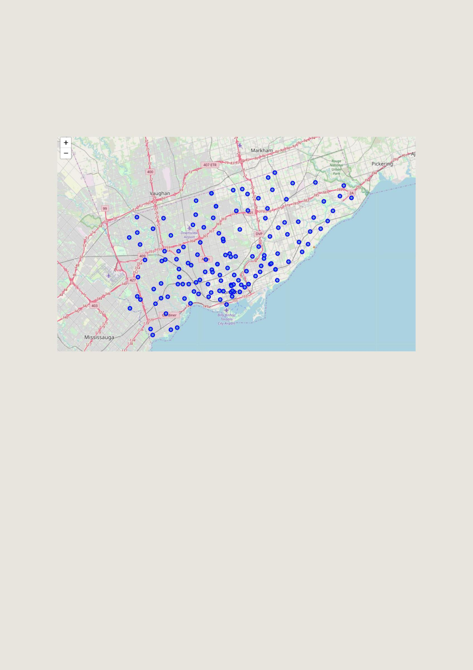
Results

The geopy library enabled us to successfully retrieve geolocation data for more than 130 of the 140 neighbourhoods. The rest was added manually. The neighbourhoods could be plotted using the coordinates with the folium library.

Fig 1. Map of neighbourhoods in Toronto using geolocation coordinates

The Foursquare API request retrieved food venues from all 140 neighbourhoods. As shown in Table 2 (column 1 and 2):

- there was a wide variation in the number of total food venues (ranged 1 to 100+), with a median of 21.

- there were very few Indian restaurants per neighbourhood (range 0 to 5), with more than half the neighbourhoods having none.

Relevant information on demographic data from the 2016 census is summarized below and shown in

Table 2 (column 3 to 9):

- Population and population density were highly variable. Some neighbourhoods were very densely populated.

- Approx. 40% of the population were in the working age

- The proportion of residents with an Indian mother tongue/south-east Asian ethnic origin varied between 0.4 to 35%.

- The proportion with an annual income of more than 50,000 CAD ranged from 8% to 49% with a median of 24.2%.

- The proportion with a university diploma or degree ranged between 11% to 79%, with a median of 38%.
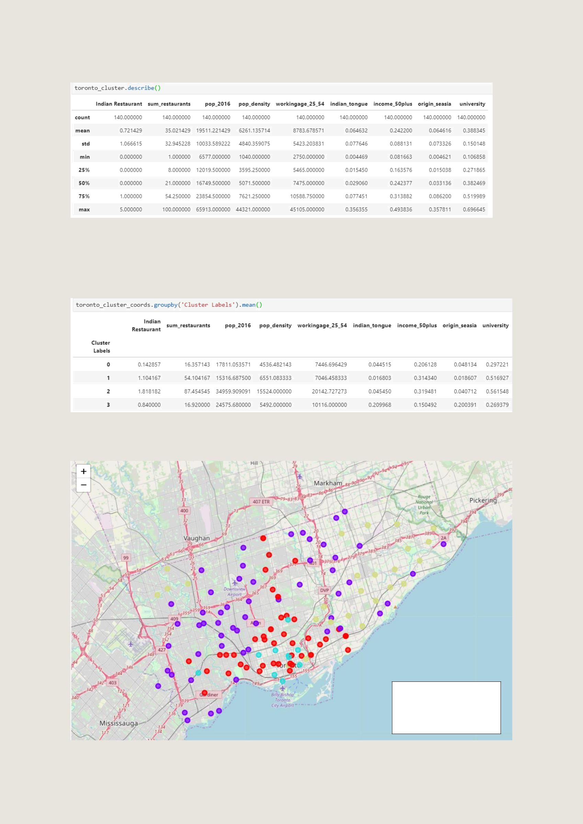
Table 2: Summary of variables in the clustering dataset

The k-means clustering with 4 clusters as described above divided the neighbourhoods into distinct clusters.

Clusters 0 to 3 had 48, 56, 11 and 25 neighbourhoods respectively. Their characteristics are summarized in Table 3.

Table 3. Mean characteristics of the four clusters

The clustered map could be displayed using folium.

Fig 2: Toronto neighbourhoods displayed with clusters marked in different colours.

Red: Cluster 0
Purple: Cluster 1
Cyan: Cluster 2

Light green: Cluster 3
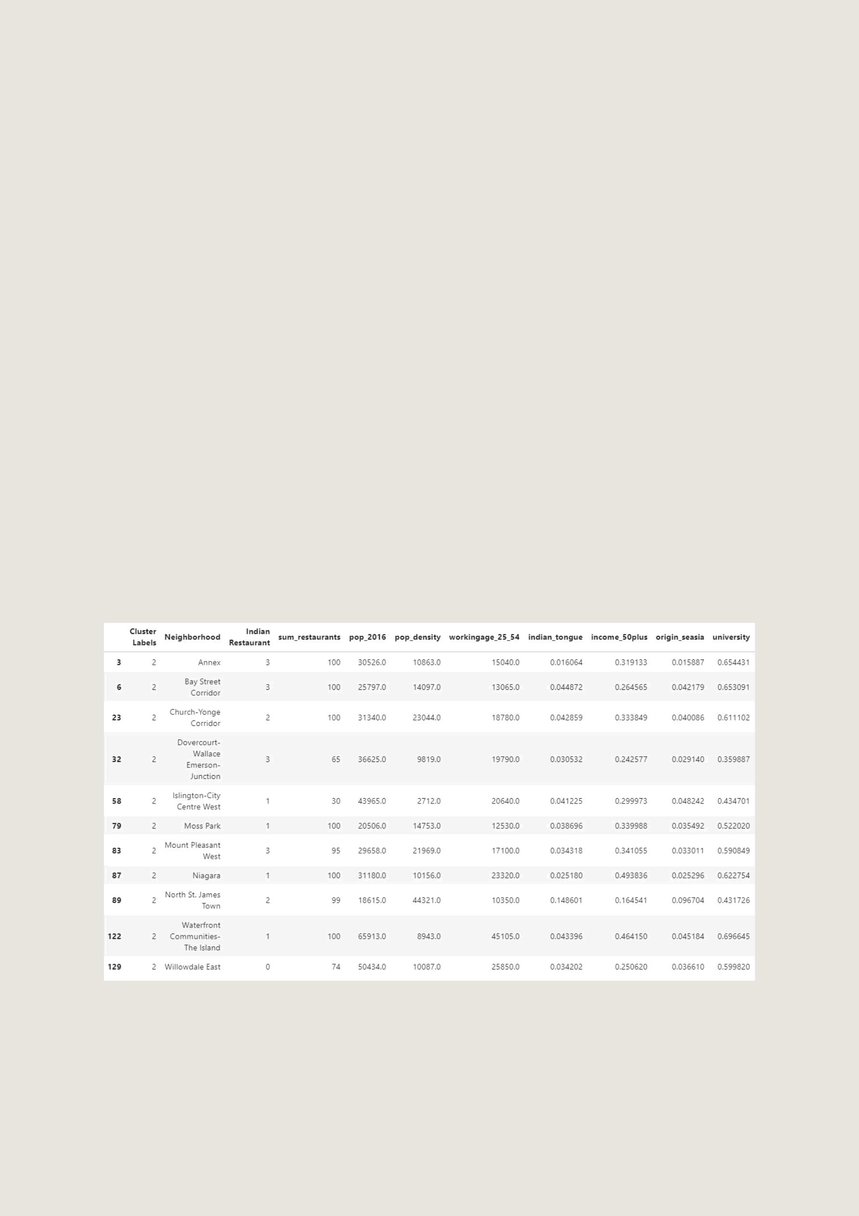
Interpretation of results

This is how I interpreted the clusters using the summary data displayed earlier:

Table 4: Summary of clusters interpreted.

 | Cluster 0 | Cluster 1 | Cluster 2 | Cluster 3
No of neighbourhoods | 48 | 56 | 11 | 25
Income | Low | High | High | Low
Education level | Low | High | High | Low
SE Asian Origin | Few | Very Few | Few | Common
SE Asian Tongue | Few | Very Few | Few | Common
Population | Low | Low | High | Moderate
Population density | Low | Low | High | Low
Working age | Few | Few | Common | Moderate
population
Total food venues | Few | Common | Common | Few
Indian restaurants | Very few | Few | Few | Relatively common
Interpretation | Not suitable for a | The population can | The population can | Ethnically closest,
 | high-end Indian fine | afford it, but large | afford, and the | but affordability is
 | diner | ethnic mismatch | population density is | an issue and they
 |  | and low population | high. | already have several
 |  | density. |  | Indian restaurants.

Based on the above data, I would recommend cluster 2 because of the income and population density. Visual inspection of the distribution of these neighbourhoods on the map show that these are centrally located and can be approached from most parts of Toronto and its suburbs.

Digging deeper, here is a list of neighbourhoods in Cluster 2 with characteristics:

Table 5: Characteristics of neighbourhoods in cluster 2

Annex, Bay Street Corridor, Dover court and Mount Pleasant West already have 3 Indian restaurants each, while Willowdale East, Waterfront Communities and Niagara have few or none and have a substantial population and purchasing power. Rental rates permitting, I would recommend one of the latter three.

Conclusions

Using demographic data and exploring the list of current food venues, it was possible to cluster neighbourhoods in Toronto into meaningful groups using a k-means clustering algorithm. One cluster could be identified as a starting point for further analysis. Within that cluster we could make further recommendations based on the data. Willowdale East, Waterfront Communities and Niagara would be the three shortlisted neighbourhoods. A similar approach could be used for other ethnic restaurants.

